

**FALL SEMESTER 2023, BSE-5B**

**SOFTWARE CONSTRUCTION LAB SEL-311**

**Lab-3 “UML, DATABASE, PROTOTYPE DESIGNING”**

**PROJECT TITLE: Hospital Management System**

**LAB INSTRUCTOR: Engr. HAMZA**

**Submission Date: October, 18, 2023**

**Task No. 1:** Create and Design of your Semester project.

**Solution: USE CASE DIAGRAM**

**SEQUENCE DIAGRAM**

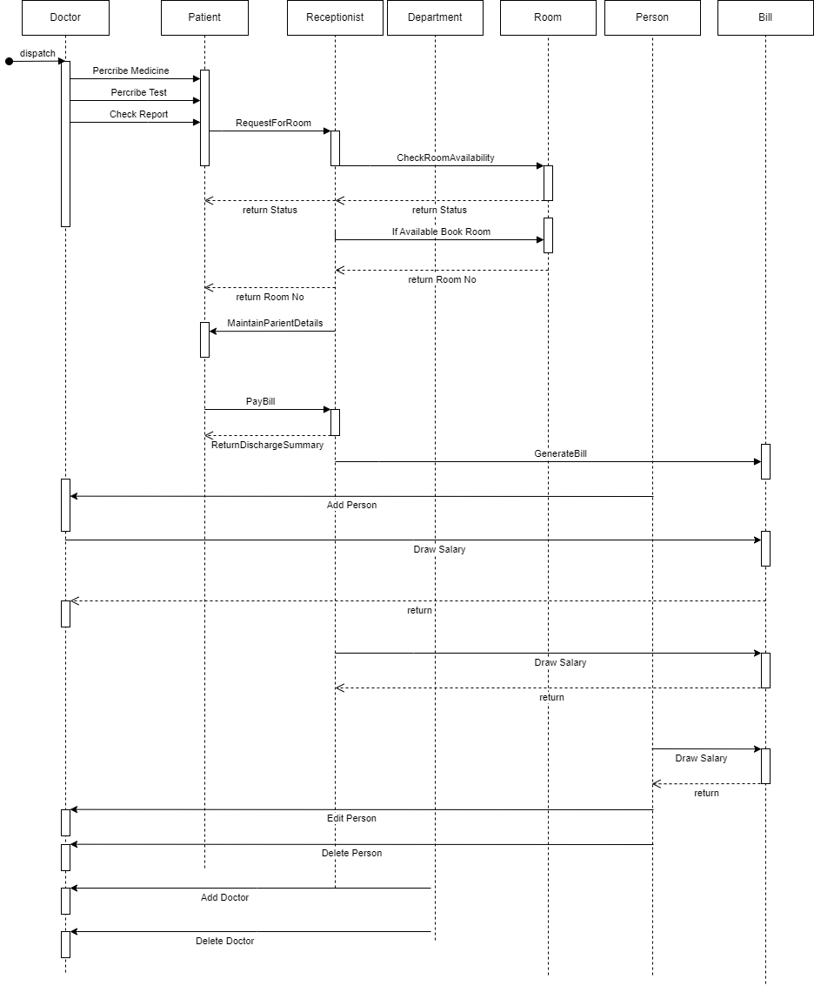

**ERD DIAGRAM**

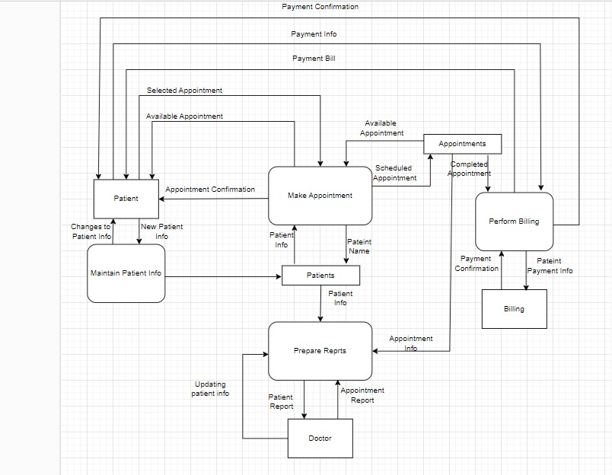**DFD DIAGRAM**

**PROTOTYPE DESIGNING**

